Choice 1- "The Generall Historie of Virginia", John Smith, 1624
At last they brought him to Werowocomoco, where was Powhatan their Emperor. Here more then two hundred of those grim [Natives] stood wondering at him, as he had been a monster. Before a fire upon a seat like a bed, Powhatan sat covered with a great robe, made of Raccoon skins, and all the tails hanging by. On either hand did sit a young girl of 16 to 18 years, and along on each side the house, two rows of men, and behind them as many women, with all their heads and shoulders painted red; many of their heads bedecked with the white feathers of birds; a great chain of white beads about their necks. At his entrance before the King, all the people gave a great shout.
The Queen of Appamatuck was appointed to bring him water to wash his hands, and another brought him a bunch of feathers, instead of a towel to dry them: having feasted him after their best barbarous manner they could, a long discussion was held, but the conclusion was, two great stones were brought before Powhatan: then as many as could lay hands on him, dragged him to them, and laid his head, and being ready with their clubs, to beat out his brains, Pocahontas the Kings dearest daughter, when no one else could succeed took his head in her arms, and laid her own body on his to protect him from death. Then the Emperor was satisfied, making him a member of his tribe, taking from him hatchets, and her bells, beads, and copper; giving him robes, shoes, bows, arrows, pots; plant, hunt, or doe any thing so well as the rest.
1.
_____________________________________________________________________________________
_____________________________________________________________________________________
_____________________________________________________________________________________
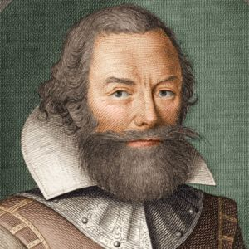
_____________________________________________________________________________________

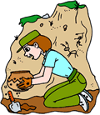
Choice 2- NOVA-Pocahontas Revealed video

1. Who is John Smith? Describe his importance as a Jamestown settler. _____________________________________________________________________________________
_____________________________________________________________________________________
_____________________________________________________________________________________
_____________________________________________________________________________________

2. What is the importance of archeology in the study of history? _____________________________________________________________________________________
_____________________________________________________________________________________
_____________________________________________________________________________________
_____________________________________________________________________________________
3. How did gender roles play a part in the Pocahontas myth? _____________________________________________________________________________________
_____________________________________________________________________________________
_____________________________________________________________________________________
_____________________________________________________________________________________
4. How does copper play a role in the Pocahontas myth? _____________________________________________________________________________________
_____________________________________________________________________________________
_____________________________________________________________________________________
_____________________________________________________________________________________
5. According to the video, what was the purpose of the elaborate ceremony John Smith was involved in when Pocahontas “saved” him?

_____________________________________________________________________________________
_____________________________________________________________________________________
_____________________________________________________________________________________
_____________________________________________________________________________________
6. Why did relations between Native Americans and Jamestown settlers deteriorate after John Smith’s encounter? What was the result?

_____________________________________________________________________________________
_____________________________________________________________________________________
_____________________________________________________________________________________
_____________________________________________________________________________________
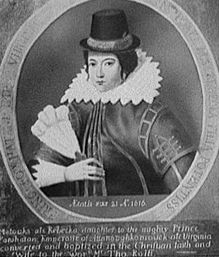

Choice 3- NOVA Pocahontas Revealed images

1.
_____________________________________________________________________________________
_____________________________________________________________________________________
_____________________________________________________________________________________
_____________________________________________________________________________________

2.

_____________________________________________________________________________________
_____________________________________________________________________________________
_____________________________________________________________________________________
_____________________________________________________________________________________
Choice 4- History Channel: Pocahontas Song

1.

_____________________________________________________________________________________
_____________________________________________________________________________________
_____________________________________________________________________________________
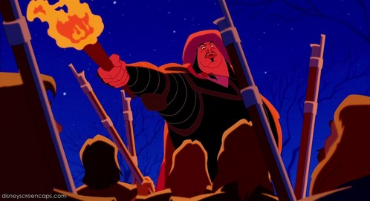
Choice 5- Disney: Pocahontas Savages

1. _____________________________________________________________________________________
_____________________________________________________________________________________
_____________________________________________________________________________________
_____________________________________________________________________________________

2. _____________________________________________________________________________________
_____________________________________________________________________________________
_____________________________________________________________________________________
_____________________________________________________________________________________
3. _____________________________________________________________________________________
_____________________________________________________________________________________
_____________________________________________________________________________________
_____________________________________________________________________________________
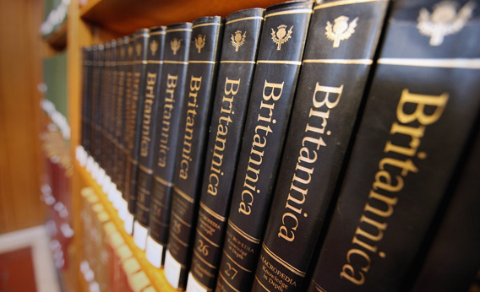
Choice 6- Encyclopedia of American History:
Pocahontas

1. _____________________________________________________________________________________
_____________________________________________________________________________________
_____________________________________________________________________________________
_____________________________________________________________________________________

Choice 7- House of Burgesses

1. _____________________________________________________________________________________
_____________________________________________________________________________________
_____________________________________________________________________________________
_____________________________________________________________________________________
